1. Let’s create one Direct and one Alternative Exchange for Demo.
2. 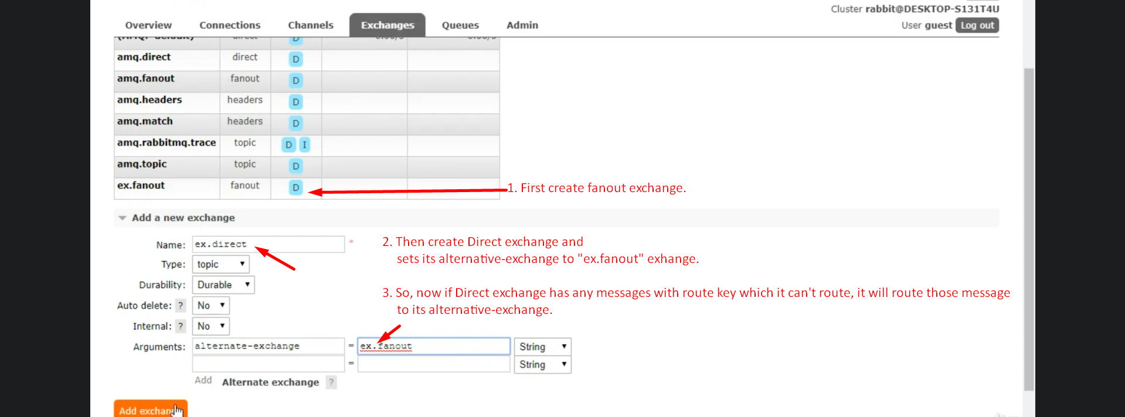
3. 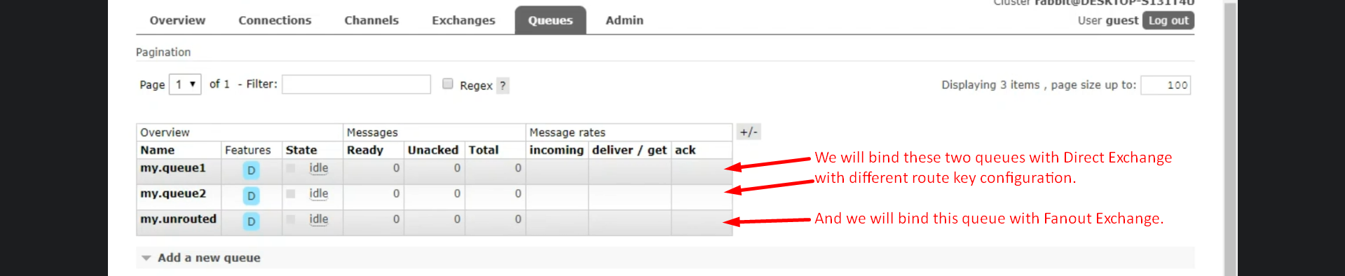
4. 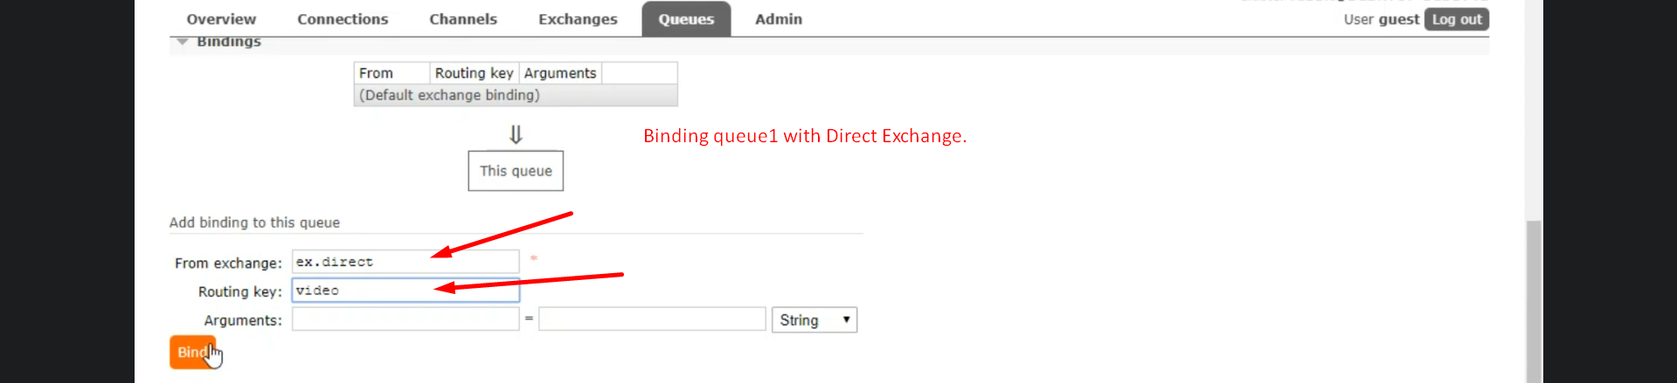
5. 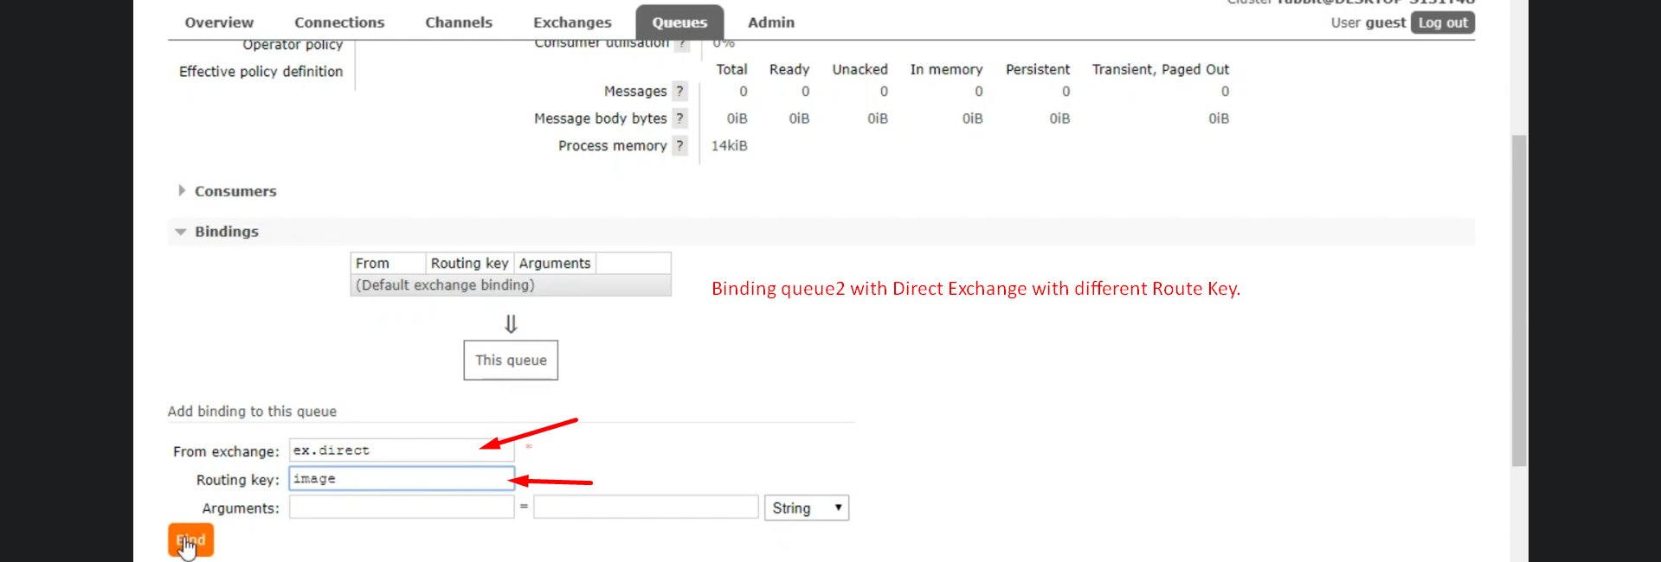
6. 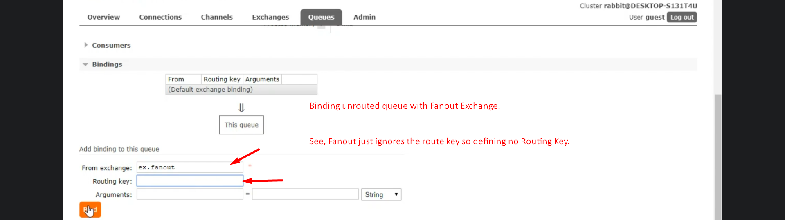
7. 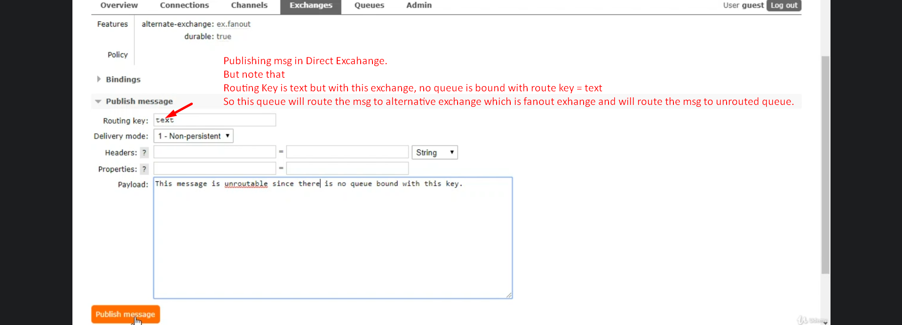
8. 